Tai Tonga 41° OCC - Ngā Mata o Te Ariki Tāwhirimātea
Event

Event Name: Ngā Mata o te Ariki Tāwhirimātea
Event Date: 25 June 2022 (back up date 26 June)
Event Location: Evans Bay, Wellington

Event Summary
Tai Tonga 41° OCC invites you to join us as we celebrate our 25th year of existence and to mark the beginning of the new year in the Māori lunar calendar. Our event named Ngā Mata o Te Ariki Tāwhirimātea marathon acknowledges Tāwhirimātea as a key element to learning and navigating Tangaroa. While the eyes (ngā mata) of Tāwhirimātea guide us through the darkness of the future, during the day we will share stories of our past and present achievements.

This event is a full day of racing and will coincide with other water vessels racing around the Evans Bay, Wellington.

Event Brief
Events: 1/2 person crafts (long and short course) and 4/6/12 person crafts (long and short course)
Divisions: Open only.
All events will have one division, open. Open division is 14-100yrs as per WANZ Race Rules. Age is taken as reaching the specified age in the year of competition.
Categories: Men, Women, Mixed
Fees:
Open W1, W2, W6 - 8km | $20pp
Open W1, W2, W6, W12 - 15km | $30pp
Open W1, W2, W6 - 8km & 15km | $40pp

All waka ama entries are to be registered online by your club rep. Clubs are to make one direct bank payment by Wednesday 22 June for all registrations to:
Tai Tonga 41 Outrigging Club 38-9011-0013609-02 ref: club name

Please ensure teams arrive and check-in on time with completed waiver forms
Registration will close midnight 19 June. We will not accept late registrations

Event Schedule

7.00am | Crew/paddler check-in and safety checks open
7.30am | Karakia/Ruruku. Welcome and 1/2 person crafts paddlers brief
8.00am | Race 1: 1/2 person crafts short and long course start
9.45am | 4/6 person crafts short course brief
10.00am | Race 2: 4/6 person crafts short course start
11.30am | 4/6/12 person crafts long course brief
12.00pm | Race 3: 4/6/12 person crafts long course start
3.00pm | Hakari, karaoke, prize-giving

Race Day Information

Weather Check
Weather apps for Evans Bay are generally quite accurate. We use Windfinder and train in conditions up to NW24 kts and SE16-19 kts. Safety is paramount and will determine the race course. Clubs are expected to ensure all their padders are adequately prepared for ultimate conditions and capable to right a waka if it should capsize.

Secured ropes ready for towing are a must for all vessels and enough buoyancy vest/jackets for all paddlers must be either worn or secured in the vessel. Spray skirts are optional unless made compulsory by the Race Director due to adverse weather conditions.

Check out our club facebook page for local information and weather forecast
https://www.facebook.com/taitonga41marathon

Waka Hire
Tai Tonga 41° OCC will not have any waka for hire. We encourage club organisers to make direct contact with other clubs for waka. Clubs are responsible for organising waka for all their registrations.

Trailer Parking
A designated free trailer parking area is available at the southern end of Evans Bay Parade. You will need to read signs and park accordingly as the ramp is a public ramp. Trailers can be left overnight at your own risk.

Please bring enough tyres for your waka and a trolley. Our club only has 1 and we would not like for anyone to be injured while carrying waka on the ramp.

There is ample free road and other parking for cars.

Food and Refreshments
We encourage you to bring your own kai. There are large grocery stores and take away shops in Kilbirnie. Less than 1km north of Evans Bay are Greta Point Cafe and Morosia bakery and cafe who provide delicious kai and coffee.

We will also be putting on a hakari (kai/food) for competitors at the end of the day. Extra meals can be purchased on the day for $10. The Evans Bay Yacht Club bar will also be open from 3.00pm, and will provide tea, coffee and drinks.

First Aid
We will have a number of first raiders who will be able to assist with minor injuries or illnesses. Please approach or alert any of the organisers wearing official vests for assistance.

Toilets
There are signed public toilets near the southern boat ramp/trailer parking area, in the Evans Bay Yacht Club and near the northern boat ramp. Ask any officials for directions.

Rubbish/Recycling
We encourage you to please bring rubbish bags for your club members and to ensure your area is cleared before leaving. There is a recycling station at the south end of Evans Bay by the camper van parking and a large bin to dispose of rubbish bags near the Evans Bay Yacht club.

Event Course

Evans Bay body of water is an inlet off the Wellington Harbour about 4km long, 700m at its most narrow point and 1.5km at its widest point. Sheltered from easterly winds by Te Motu Kairangi or Mirimar Peninsula, and westerly winds by Whātaitai or Hātaitai hill.

With the airport just 5.5km from Evans Bay Yacht Club or 5 minutes drive and a number of hotels in nearby suburbs Miramar, Kilbirnie and Hataitai this race can easily be a day trip for anyone who wishes to fly to Wellington.

The exact race course will not be determined until the day. The 8km course will most probably be around the southern end of Evans Bay where supporters and spectators can watch from the Yacht Club.

The 15km course will span the whole Evans Bay area without going into the main Wellington Harbour.
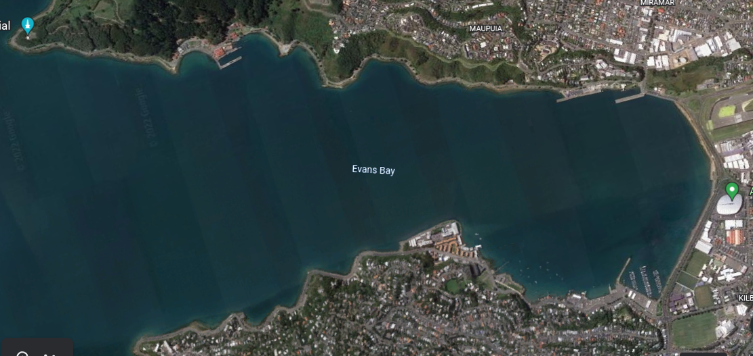
Airport
Airport
Yacht Club
Race Venue

